What is trauma informed counseling?
Trauma informed counselors work with the client and their experience of trauma by being sensitive to how trauma affects the mind, body, spirit, and the client’s perception of the world. While maintaining a calm, safe environment in which to discuss the trauma, counselors work to avoid re-traumatizing the client through helping them release intense emotion left over from the traumatic event.
This is done using evidence-based methods and counseling techniques. The goals of the approach include enabling the client to process their past trauma experiences, help them regain a positive sense of self, and reestablish a healthy quality of life. Because each client experiences trauma differently, the time it takes to accomplish these goals, as well as the forms of treatment used, can vary from person to person.
Trauma affects people’s ability to function in different ways and treating the effects of trauma requires an understanding of the processes and connection between the brain and body. The diagram below shows some of the effects of trauma-related stress on the body, mind, emotions, and behavior. Each individual may experience some or all of these effects.
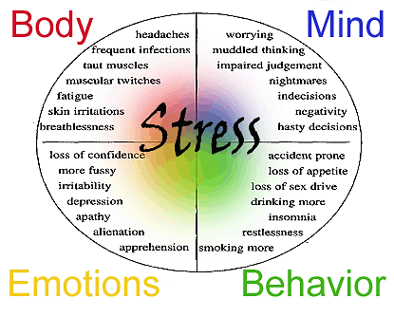
How Does Stress Affect the Brain and Body?
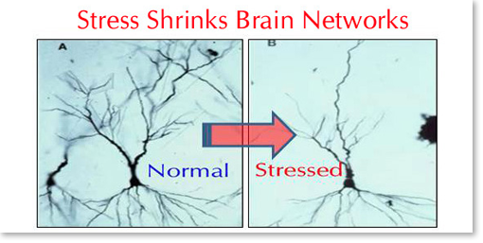
Neurobiology refers to the connections and interactions between a person’s brain and body. Research has found that trauma and stress physically affect the brain and can cause changes in the brain structure. The physical changes in the brain lead to alterations in the chemical makeup and pathways in the brain and body, which causes changes in emotions, thoughts, and behavior. The picture below shows the difference in the brains neural pathways when someone is stressed and shrinking occurs.

These alterations can cause emotions and thoughts to become confusing, immobilizing, and overwhelming, ultimately causing a person to be in a constant state of stress. The effect of stress and trauma on the body and brain, often results in activation of the “fight-flight-or-freeze” response, which prohibits healthy functioning. A person can become “stuck” in the dysfunctional patterns created by stress, causing them to relive and physically experience the trauma and related negative emotions.
Understanding the way that trauma alters brain function enables counselors and clients to work toward reestablishing healthy brain-body connections. Rebuilding healthy pathways can help a client create positive patterns of emotions, thoughts, and behaviors. Techniques such as biofeedback can help clients ease the symptoms of stress and trauma, and help them rebuild effective, healthy, brain-body pathways.

What is biofeedback?
Biofeedback uses the signals from a person’s body to indicate what is going on below the surface, acting as a sixth sense. Output of biofeedback techniques provides a visual representation of how the brain, heart, and related systems are interacting. Biofeedback, using Heart Rate Variability (HRV), offers a way for client’s to learn how to effectively address the effects of stress (anxiety, depression, trauma, sleeplessness, etc.), by seeing how the body physically reacts during times of stress, relaxation, and contentment. Techniques such as mindfulness, focused attentional breathing, and recreating positive feelings can all be used to help the individual shift their moods and emotions, as well as minimize physical responses to trauma, pain, and stressors.

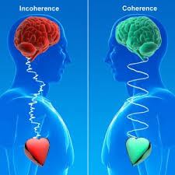
Using a sensor, such as the emWave Pro, and corresponding application, to measure HRV, the counselor is able to educate the individual about how the signals from their heart and brain work together. The application and visual representation show the client when those signals are out of sync, indicating the person is experiencing some form of stress within their system, and experiencing incoherence. The counselor can use the technology and focus techniques to help the client synchronize signals working between their heart and brain, ultimately helping them relieve symptoms related to trauma and stress, and returning them to a higher, more coherent state of functioning.
Similar to learning a new sport, the Biofeedback program coaches clients through learning new skills and provides suggestions on how to improve performance. As a client begins learning and refining their skills, the program offers tones, spoken guidance, and visual tools to help the client make corrections that adjust the signals they are receiving and increase their ability to more easily shift into coherence whenever it may be needed.
When using HRV biofeedback daily, one can experience improvements in as few as three weeks, however, the desired time frame for guided sessions with a counselor is six to nine weeks. Improvements can be seen in the ability to focus, quality of sleep, increased calmness, reduced anxiety and fatigue, and a decrease in symptoms related to depression and stress. Results will continue to improve with ongoing daily use throughout one’s lifetime.

